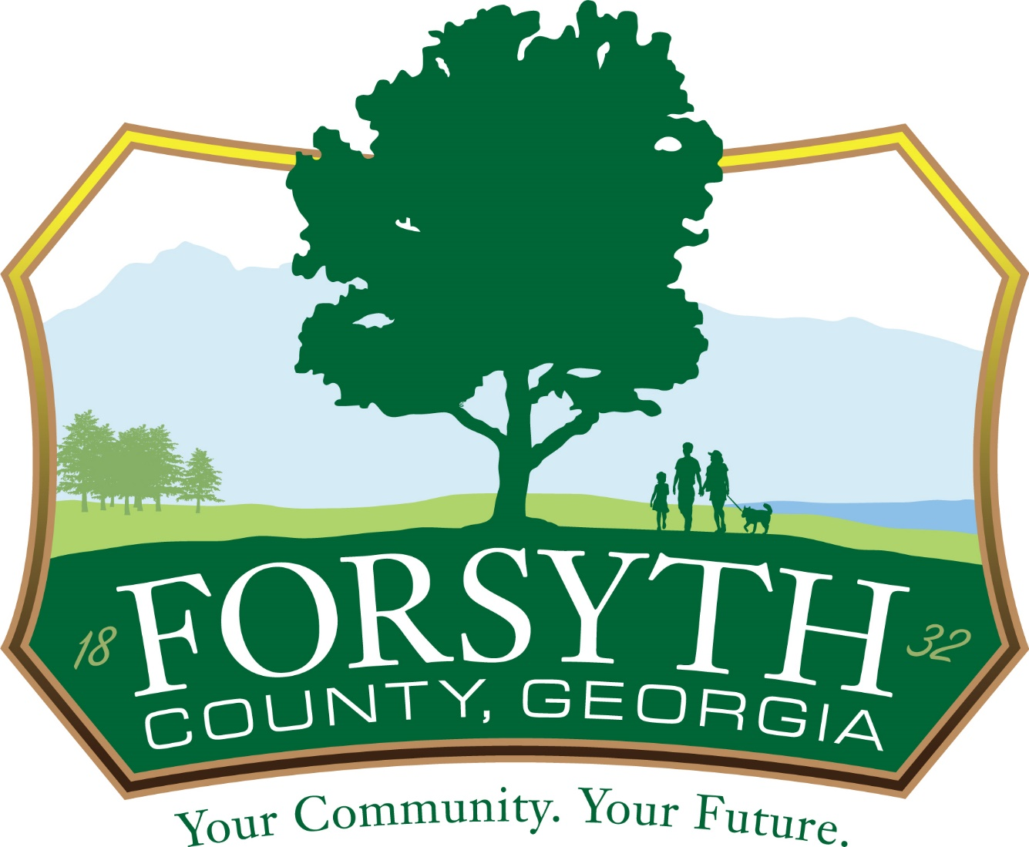
HYBRID SOLICITATION OPENING INSTRUCTIONS

All solicitations must be delivered to the Forsyth County Procurement Department, 514 West Maple Suite 104, Cumming, GA 30040 by 02:00 p.m. (local time) February 10, 2022. Names of firms submitting proposals will be read aloud.

As of July 1st, a maximum of 7 individuals will be allowed to attend the Solicitation Openings in person. These spots are first come first serve, with one individual per firm.

BID 22-01-3340 Hurt Bridge Road Water Transmission Mains
BID 22-03-3150 Trammel Road Right Turn Lane at SR210
Topic: Solicitation Opening
Time: Feb 10, 2022 02:30 PM Eastern Time (US and Canada)

Join from PC, Mac, Linux, iOS or Android: https://us06web.zoom.us/j/84753620503

Or Telephone:
Dial:
USA 602 333 0032
USA 8882709936 (US Toll Free)
Conference code: 155654

Find local AT&T Numbers: https://www.teleconference.att.com/servlet/glbAccess?process=1&accessNumber=6023330032&accessCode=155654

Posted: 2/7/22

